The Bengali Supper Club

The Spiced Hawk journey continues from the North East to Bengal where the cuisine is rich and varied. Streetfood, fish and Chinese Influences are highlights of the this cuisine.We will wander around India over the next few months with a few people. Our journey will continue next week to sample the delights of the cuisine of Hyderabad and Andhra Pradesh.
Friday 1st November
£30.00 per person

Nibbles
Puffed Rice tossed with red and orange cherry tomato and onions, coriander

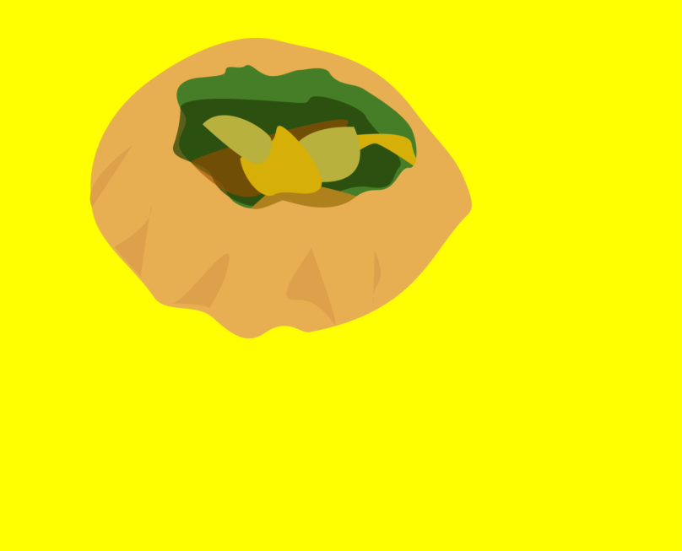
Puffed wheat stuffed with mungbean sprouts, boiled potato served with tamarind water

Starter
Calcutta Kathi Roll
Grilled chicken with pickled onions wrapped in a wholewheat paratha bread served with coriander and mint chuteney
Or
Potato and chickpeas, pickled onions wrapped in a wholewheat paratha bread served with a coriander and mint chutney

Mains

Bengali Tilapia Fish Curry with mustard and cream
Or
Indo-Chinese Szechuan Paneer Curry with spring onions, tomato, ginger, garlic

Sides

Baby Potatoes tossed in a lightly spiced poppy seeds paste
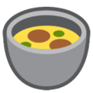
Bengali Masoor Daal with five spices

Indo Chinese Szechuan Cauliflower with spring onions, ginger and chilli

Basmati Rice

Pudding

Jaggery sweetened yoghurt with Pernod toasted oats

