North East Indian Supper Club
£30.00 per person
Friday 25th October
The Spiced Hawk based at the Beaufort Polo Club is delighted to present the start of our weekly supper clubs.
Come and join us on a journey round India every Friday encompassing the very interesting contrast in regional cuisines.
We start with an evening of food from the North East of India.

Nibbles

Assam Tea Steeped Chickpeas with Masala Chai salt

Starters

Smoked Pork in Brandy with Pickled Pork served with a Chilli Chutney

Or

Wild Mushrooms with Bamboo shoots served with Chilli Chutney

Mains

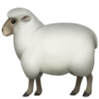
Assamese Mutton Curry

Or

Cottage Cheese cooked in Milk

Sides

Pumpkin and Black Beans Daal

Green Pea Curry

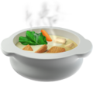
Vegetable Stew

Rice with black sesame

Pudding

Coconut & Milk Pudding

